|  |
| --- |
|  |
|  |

|  |  |  |  |  |  |
| --- | --- | --- | --- | --- | --- |
| REVISION HISTORY | | | | | |
| Ver. | Description of Change | Author | Date | Approved | |
| Name | Effective Date |
| 1.0 | Initial status | [Kiryl Bucha](mailto:Kiryl_Bucha@epam.com) | 12-JAN-2012 |  |  |
| 2.0 | Updated in accordance with renewed content | [Elias Nema](mailto:Elias_Nema@epam.com) | 20-JAN-2014 |  |  |
| 3.0 | Report | Mikita Tur | 10-DEC-2017 |  |  |

Contents

1. Create Packages for Reload Dimension from DW to SAL 3

2. Test Your Data 3

3. Task Results 3

# Create packages to load dimensions from ST (staging) to SL (star layer)

The Main Task is to create independent packages to reload dimensions according to your DWH solution concept that was developed on Module 6 Introduction to DWH.

Required points:

* Create all required dim objects on SL Layer
* Grant all required privileges to SL_CL (Cleansing Layer)
* Create packages to load dim data (one package = one dimension) on SL_CL
* Use Bulk Collect (One or more procedures)
* Use Forall (One or more procedures)
* Use a cursor FOR loop
* Use EXECUTE IMMEDIATE INTO for dynamic queries
* Use cursor variables

All required tables were created. The scripts are in the project folder.

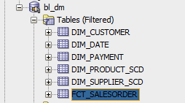

STAR Shema:

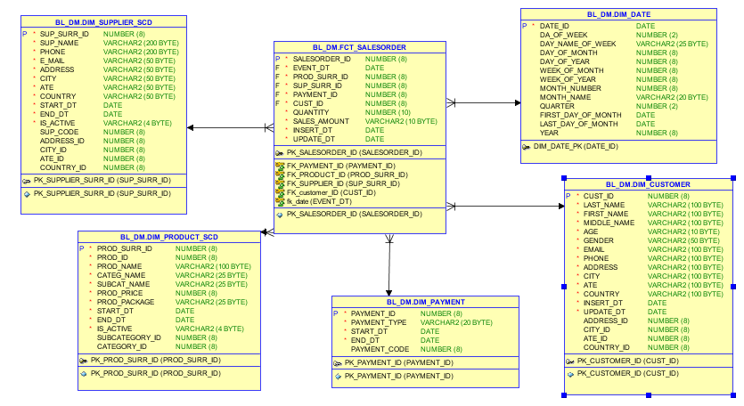

Tables which are loaded from bl_3nf to bl_dm firstly move to bl_cl and names BL_CL.CLS2_//:

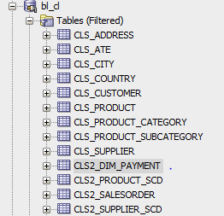

Package to insert data from bl_cl.cls2.. to bl_dm

CREATE OR REPLACE PACKAGE pkg_etl_insert_products

AUTHID CURRENT_USER

AS

PROCEDURE insert_table_products;

PROCEDURE merge_table_products;

END pkg_etl_insert_products;

CREATE OR REPLACE PACKAGE BODY pkg_etl_insert_products

AS

---------------------------------------------------

PROCEDURE insert_table_products

IS

BEGIN

EXECUTE IMMEDIATE ('TRUNCATE TABLE cls2_product_scd');

insert into CLS2_PRODUCT_SCD(PROD_SURR_ID,

PROD_id ,

PROD_NAME ,

CATEG_NAME ,

SUBCAT_NAME ,

PROD_PRICE ,

prod_package ,

START_DT ,

END_DT ,

IS_ACTIVE )

select cp.product_id as prod_surr_ID,cp.PRODUCT_srcID as prod_id,

cp.product_name,

ct.category_name,

sc.subcategory_name,

cp.product_price,

cp.product_package,

cp.start_dt,

cp.end_dt,

cp.is_active

from BL_3NF.CE_PRODUCT cp left join( BL_3NF.CE_PRODUCT_SUBCATEGORY

sc left join BL_3NF.CE_PRODUCT_CATEGORY ct on sc.category_srcid=ct.category_srcid ) on cp.SUBCATEGORY_SRCID=sc.SUBCATEGORY_SRCID;

END;

COMMIT;

EXCEPTION

WHEN OTHERS THEN

RAISE;

END insert_table_products;

---------------------------------------------------

PROCEDURE merge_table_products

IS

BEGIN

MERGE INTO bl_dm.dim_product_scd tgt USING

(SELECT prod_surr_id,

PROD_NAME ,

CATEG_NAME ,

SUBCAT_NAME ,

PROD_PRICE ,

prod_package ,

START_DT ,

END_DT ,

IS_ACTIVE

FROM CLS2_PRODUCT_SCD

MINUS

SELECT PROD_id ,

PROD_NAME ,

CATEG_NAME ,

SUBCAT_NAME ,

PROD_PRICE ,

prod_package ,

START_DT ,

END_DT ,

IS_ACTIVE

FROM bl_dm.dim_product_scd tgt

) src ON (tgt.prod_name=src.PROD_NAME AND tgt.prod_price=src.prod_price AND tgt.prod_package=src.prod_package)

WHEN matched THEN

UPDATE

SET tgt.prod_id = src.prod_surr_id,

tgt.END_DT =src.end_dt,

tgt.IS_ACTIVE =src.is_active WHEN NOT matched THEN

INSERT

(

prod_surr_id,

PROD_id ,

PROD_NAME ,

CATEG_NAME ,

SUBCAT_NAME ,

PROD_PRICE ,

prod_package ,

START_DT ,

END_DT ,

IS_ACTIVE

)

VALUES

(

bl_dm.dim_prod_seq.NEXTVAL,

src.prod_surr_id,

src.PROD_NAME ,

src.CATEG_NAME ,

src.SUBCAT_NAME ,

src.PROD_PRICE ,

src.prod_package ,

src.START_DT ,

src.END_DT ,

src.IS_ACTIVE

) ;

COMMIT;

EXCEPTION

WHEN OTHERS THEN

RAISE;

END merge_table_products;

---------------------------------------------------

END pkg_etl_insert_products;